Republic of the Philippines

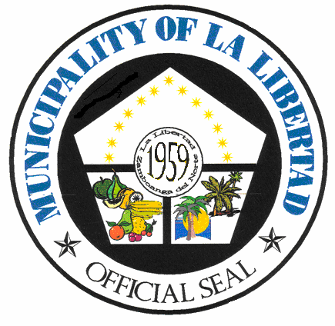
MUNICIPALITY OF LA LIBERTAD

Government Center, Poblacion, La Libertad, Zamboanga del Norte 7119 Philippines
Email Address: lgulalibertad@gmail.com

MUNICIPAL CIVIL REGISTRY OFFICE
Ground Floor, Government Center, Poblacion, La Libertad, Zamboanga del Norte 7119 Philippines

Email Address: lcrlalibertadzn@gmail.com Cell No. 0950-769-6044
= = = = = = = = = = = = = = = = = = = = = = = = = = = = = = = = = = = = = = = = = =

R. A. Form No. 8.1 (LCRO)

MUNICIPALITY OF LA LIBERTAD

Government Center, Poblacion, La Libertad, Zamboanga del Norte 7119 Philippines
Email Address: lgulalibertad@gmail.com

NOTICE OF POSTING
Petition No.:
The public is hereby notified that has filed with this Office a Petition for Change of Gender in the Certificate of Live Birth of with Registry No. .
ENTRY/IES SUBJECT FOR POSTING
Item No. | Description | From | To

Any person claiming interest or may be adversely affected by said petition, may file his/her written opposition with this Office within ten (10) calendar days.
Date:

ANNABELLE M. PAMERON
Municipal Civil Registrar

R. A. Form No. 9.1 (LCRO)

MUNICIPALITY OF LA LIBERTAD

Government Center, Poblacion, La Libertad, Zamboanga del Norte 7119 Philippines
Email Address: lgulalibertad@gmail.com

CERTIFICATE OF POSTING

This is to certify that Petition No. dated filed by for the under Registry No has been posted for ten (10) consecutive days from to at the Civil Registry Office Bulletin Board in compliance with Section 6 of R.A. No. 10172:
ENTRY/IES SUBJECT FOR POSTING
Item No. | Description | From | To

Issued at the Local Civil Registry Office of La Libertad, Zamboanga del Norte this ^{th} day of .

ANNABELLE M. PAMERON
Municipal Civil Registrar

